Document Name: | Clinical Model for Inpatient Care in the New Park House Development
Executive Summary: | This model of care describes the care a patient can expect during an admission to the in-patient unit. It describes the values underpinning the service, and clarity about who the service is for, as well as confirming the place of in-patient services within the whole clinical pathway. The model describes the service offer, the key care principles beneath it, and the interventions which are available.  The staffing model to deliver the service, is appended to the clinical model of care.
Executive Lead: | Deborah Partington, Executive Director of Operations
Document Author: | Deborah Goodman
Document Purpose: | Description of model for working in New Park House Development
Target Audience: | All staff working within Park House or participating in the development of the New Park House
Additional Circulation List: | Not Applicable
Date Ratified:
Ratified by: | Executive Management Team
Consultation: | NPHD Workstream 1 Group  Older People’s management team  Network hubs  Multi-Disciplinary Engagement leads  Professional Engagement leads
Cross Reference: | CPA policy  Positive and Safe Strategy  Patient Flow Standard Operating Procedure  Clinical risk policy
Date of Equality Impact Assessment: | 19 May 2020 for OBC  Revised for FBC
Board Objective Reference:
CQC Regulation Reference/Other mandatory requirements: | Requirement of the Outline Business Case for the new development
Risk Register Reference:
Contact Details for further information | Deborah Goodman, Associate Director of Operations
Document Status | This is a controlled document. Whilst this document may be printed, the electronic version posted on the Trust intranet is the controlled copy.
Description of document changes in this review to aid Consultation Process:
It is essential that this box is completed by the author. This is so that staff consulting on the document and all Trust staff post-approval are aware of the main changes to the existing document, and it enables changes to be communicated more effectively in the Services.

- 31 July OBC approved by GMMH Board for submission to NHSE/I
- 27 November Updates requested from workstream 1 leads
- 4 January Narrative received incorporated in red into v5
- 5 January Draft with residual areas for completion in yellow v6
- 6 January draft with updated contents page
- 26 January 2021 draft with residual areas for completion in yellow v9

The Document Pre-approval Checklist below should be completed prior to submission of the draft for ratification. It will be kept separate from this document once issued to aid clarity of reading and reference. Double click on the icon below to open the file for completion.

Contents

Schedule of Abbreviations ……………………………………………………………………………………6
1. Introduction…………………………………………………………………………………………………..8
2. Values and Philosophy……………………………………………………………………………………9
3. Whole System…………………………………………………………………………………………………10
4. Aims of the Service…………………………………………………………………………………………12
5. Who the inpatient service is for:…………………………………………………………………….13
5.1 Referral Criteria for all service users 13
5.1a Additional Criteria for older adults (defined by the Royal College of Psychiatrists) 13
5.2 CAMHS and admission of 16/17 year olds 13
5.3 When is a service user likely to be admitted? 13
5.4 When would someone be unlikely to be admitted? 13
6. Referral process/Patient flow……………………………………………………………………..14
6.1 Section 136 suite 17
7. Clinical Pathway……………………………………………………………………………………………….17
8. Service offer within the clinical pathway…………………………………………………………17
8.1 Admission 17
8.2 Assessment of need 20
8.3 Assessment of risk 20
8.4 Psychiatric Intensive Care Unit (PICU) 21
8.5 Collaborative care planning 21
8.6 Key Care Strategies 22
8.6.1 Quality Improvement 22
8.6.2 Red2Green 22
8.6.3 Infection Prevention and Control 22
8.6.4 Positive and safe 22
8.6.5 Safewards 23
8.6.6 Safeguarding 23
8.6.7 Mental Health Act, Mental Capacity Act and dols 23
8.6.8 Digital Technologies 23
8.6.9 Fire safety 24
8.7 Interventions 24
8.7.1 Psychological Care 24
8.7.2 Managing difficult emotions (MDE) pathway 24
8.7.3 Assessment of and support with occupational needs and activities of daily living 24
8.7.4 Support for substance misuse difficulties 24
8.7.5 Support with housing issues 25
8.7.6 Support for family/carers. 25
8.7.7 Support with physical health 25
8.7.8 Medicines Management 26
8.7.9 Electroconvulsive Therapy (ECT) 26
8.7.10 Suicide prevention 26
8.7.11 Audit 26
8.8 Discharge planning 27
8.8.1 Supportive Discharge Planning……………………………………………………………………28
8.8.2 Rehabilitation 28
8.9 End of life care 28
8.10 Care of patients with Dementia 29
9. Staffing model to deliver this service offer…………………………………………………30
10. Partnerships and interfaces…………………………………………………………………………30
10.1 Working with carers and families 30
10.2 Working with patient flow 30
10.3 Working with Home Based Treatment and Intensive Support Service 31
10.4 Working with cmhts 31
10.5 Working with the Local Authority 32
10.6 Working with the acute Trust 32
10.7 Record keeping 32
11. Facilities supporting recovery………………………………………………………………………..33
11.1 Café 33
11.2 Gym 33
11.3 Exercise space 33
11.4 Spiritual hub 33

Appendices
- Patient Flow Standard Operating Procedure Draft 9
- Red2Green Days
- Safeward interventions
- Stepped Care Model for Psychological interventions
- Managing Difficult Emotions pathway
- Stepped Care Model for Occupational Therapy
- Draft Annual Audit Programme 2021-2022
- Standards and Guidance on Board Rounds
- Standards and Guidance on Ward Rounds
- Staffing model
- Policy for Transfer of service users to acute care

Schedule of Abbreviations
A schedule of abbreviations used in this document is set out below:

Schedule of Abbreviations
AMHU | Adult Mental Health Unit
AMHP | Approved Mental Health Professional
ATAC | Acute Triage and Care Planning
ATU | Assessment and Treatment Unit
AWOL | Absent Without Leave
BAU | Business as Usual
CAMHS | Child and Adolescent Mental Health Service
CFT | Compassion Focused Treatment
CMHT | Community Mental Health Team
CPA | Care Programme Approach
CPR | Cardio Pulmonary Resuscitation
CQC | Care Quality Commission
CQUIN | Commissioning for Quality and Innovation
CT | Core Trainee (Doctor)
DNR | Do Not Resuscitate
ECG | Electrocardiogram
ECT | Electroconvulsive Therapy
EDD | Estimated Date of Discharge
FY | Foundation Year (Doctor)
GMMH | Greater Manchester Mental Health NHS Foundation Trust
HBT | Home Base Treatment
HoNOS | Health of the Nation Outcome Scores
HTT | Home Treatment Team
IAPT | Improving Access to Psychological Therapies
ILS | Immediate Life Support
IPC | Infection prevention and control
KPI | Key Performance Indicator
LoS | Length of Stay
LSU | Low Secure Unit
M&B Unit | Mother and Baby Unit
MCC | Manchester City Council
MDE | Managing Difficult Emotions
MDT | Multi-Disciplinary Team
MFT | Manchester University NHS Foundation Trust
MHA | Mental Health Act
MHLS | Mental Health Liaison Service
MSE | Mental State Examination
MSU | Medium Secure Unit
NICE | National Institute for Health and Care Excellence
NMGH | North Manchester General Hospital
OA | Older Adult
OAP | Out of Area Placement
OT | Occupational Therapy
PbR | Payment by Results
PHIT | Physical Health Intervention Tool
PICU | Psychiatric Intensive Care Unit
PMVA | Prevention and Management of Violence and Aggression
QI | Quality Improvement
RCPsych | Royal College of Psychiatrists
SAFIRE | Swift Assessment for the Immediate Resolution of Emergencies
SLA | Service Level Agreement
SMI | Severe Mental Illness
ST | Specialist Trainee (Doctor)
STR | Support Time & Treatment (worker)
SU | Service User

Introduction
The Trust is committed to providing a service that delivers high quality multi-disciplinary care and treatment, that is:
- Safe
- Caring
- Responsive
- Effective
- Well led
This clinical model of care focusses on the acute inpatients service. The New Park House Development will include 6 x 17 bedded wards and 1x18 bedded ward for adults of working age, plus a 10 bedded PICU, and a 20 bedded ward for Older Adults. The Older Adults ward provides care both for those with organic or functional illness; an arrangement that has the support of local clinicians and the Royal College of Psychiatrists accreditation scheme.
Where elements of the model relate specifically to Adults of Working Age or Older Adults, this is indicated.
The Model of Care is delivered and governed under the following statutory frameworks:
- Mental Health Act 1983 (Amended 2007) and Code of Practice
- Human Rights Act 1998
- Mental Capacity Act 2005 and Code of Practice
- The Care Act 2014
The highest professional and service standards are maintained through adherence to the process of regulation, governance and guidance from:
- NICE
- CQC
- General Medical Council
- Health and Care Professionals Council
- Nursing and Midwifery Council
- Department of Health and Social Care
- Professional Bodies
The development of the model of care has taken account of all elements of the “Nicholson” tests for service reconfiguration, with support from GPs and Clinical Commissioning Groups coming via engagement with MHCC Executive Team and MHCC Strategy Committee; Public and patient engagement via face to face conversations, virtual presentations, and workbooks; new and established ways of working based on current clinical evidence; and every element of the model supporting an improved quality of service provision.
The term “patients” is used throughout this document, to refer to people on in-patient wards, and as the preferred term both of those currently receiving care on the wards, and staff providing care. The term “service user” refers to people receiving care outside hospital.

Values and Philosophy
The philosophy of care provided on the inpatient wards is based on three main approaches which are indicative of modern mental health care: Recovery, psychologically informed environments, and a trauma-informed approach. The approaches overlap but have in common the centrality of people’s psychological as well as medical and social needs, the prevalence of trauma and adversity in the development and maintenance of distress, and the role of empowerment, person-centred, and strengths based care.
These approaches facilitate patients being supported and enabled to be central in their own care and treatment and receiving a package of care which is meaningful to them.
Care delivery is underpinned by the Core Values of the Trust; We Inspire Hope; We Work Together; We are Caring and compassionate; We value and respect; We are open and honest.

Whole System
The following diagrams show the whole system for adults of working age, and the whole system for older adults, both with their focus on enhanced community care, and showing where the in-patient element sits within this:
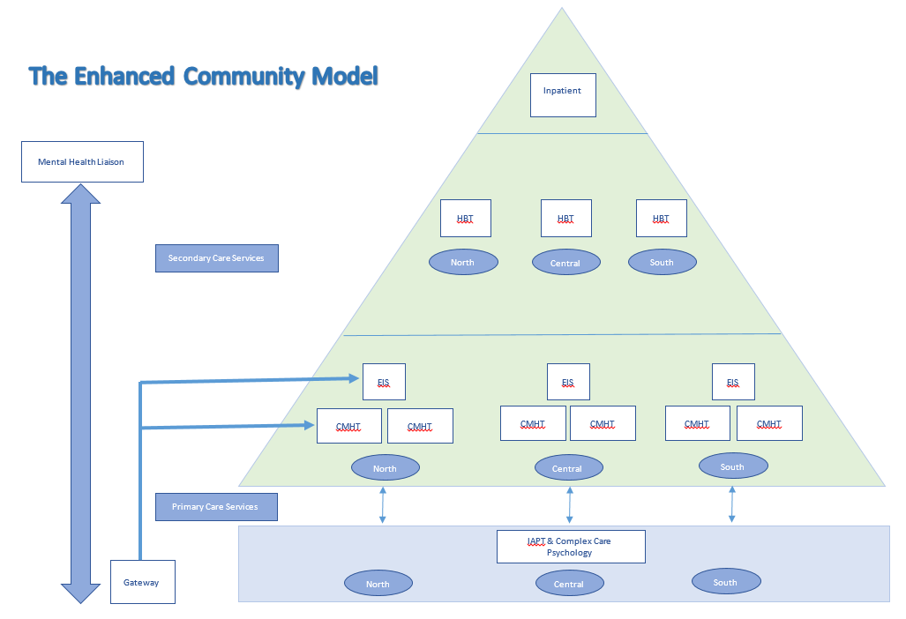
Figure 1: Whole system model for adults of working age

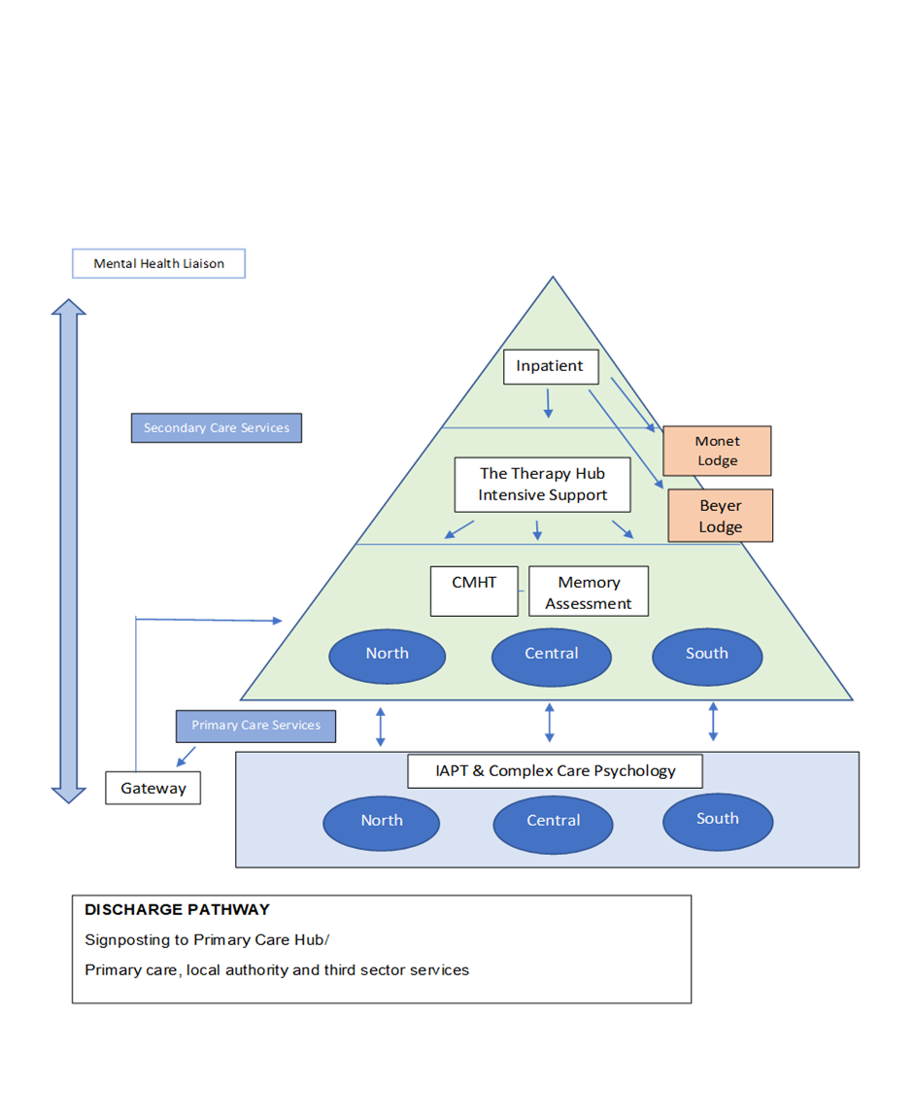

Figure 2: Whole system model for Older Adults

Aims of the Service
- There are three overarching aims of the service:
- To offer a high quality of care and treatment to adult service users experiencing an acute episode of mental health difficulties, including access to medical, psychological, nursing, social worker, and allied health professional interventions
- Promoting a positive experience for those using the service during a period of crisis, even in the context of an involuntary admission
- Care delivered by a highly skilled, engaged and compassionate workforce

Within these aims, we aspire:
- To provide assessments, treatment and multi-disciplinary care, 24 hours a day, 7 days a week, 365 days a year to patients experiencing acute mental health
problems, that are present to such a degree/nature that they cannot be safely managed in the community
- To ensure effective discharge planning including effective crisis plans and where appropriate long-term placements
- To ensure appropriate screening of and monitoring of any physical health needs and ensure appropriate treatment
- To provide access to and choice of psychosocial and therapeutic activities
- To promote recovery and social inclusion ensuing all staff work in partnership with statutory and non-statutory services, and care is delivered through a joint and integrated model.
- To ensure that patients have access to advocacy and that their rights are upheld
- To involve families and carers to the extent agreed with the patient.

Who the inpatient service is for:

Referral Criteria for all service users
- For people who are experiencing an acute episode of mental health difficulties who cannot be cared for in a less restrictive setting e.g. home
- People aged 18 upwards
- People who reside and / or are GP registered within Bolton, Salford, Trafford or Manchester (exceptions to this may be considered in light of the Trust bed management policy)

5.1a Additional Criteria for older adults (defined by the Royal College of Psychiatrists)

- People of any age with a primary dementia
- People with mental disorder and physical illness or frailty which contribute to, or complicate the management of their mental illness. This may include people under 65
- People with psychological or social difficulties related to the ageing process, or end of life issues, or who feel their needs may be best met by a service for older people. This would normally include people over the age of 70

CAMHS and admission of 16/17 year olds
- Service users under the age of 16 must not be admitted to an adult inpatient bed (but will be considered by the under-16 CAMHS service, or paediatric services both of which are hosted by the acute trust)
- A 16/17 year old may only be admitted to an adult bed whilst awaiting a CAMHS gatekeeping assessment.

5.3 When is a service user likely to be admitted?
- Where the assessed mental health needs, level of acuity and risk of an individual adult exceed the threshold of HBT and cannot be safely managed in the community
- Where the assessed mental health needs of an older adult cannot be supported by community or intensive support
- Where the safety of carers, family, and the community cannot be adequately preserved with the individual’s ongoing presence
- Where an individual needs a compulsory admission following detention under the Mental Health Act

When would someone be unlikely to be admitted?
- Individuals in need of temporary respite care
- Individuals with a primary diagnosis of learning difficulties who do not have a dual diagnosis
- Individuals primarily seeking an alcohol detox
- Individuals with a primary diagnosis of acquired brain injury who do not have a dual diagnosis
It may be the case that for some individuals an inpatient stay may be the safest option at the time for themselves and for others even where it is recognised that inpatient care cannot provide the optimum treatment. In such circumstances the care team will provide support and interventions to that individual and work with partner agencies to secure a more appropriate setting as soon as possible.

Referral process/Patient flow
Figures 3 and 4 overleaf show the referral processes for Adults of Working Age, and Older Adults.
An in-patient admission is part of a person’s wider recovery journey, rather than being an entirely separate episode of care. All service users, including those detained under the MHA, will have had a gatekeeping assessment, by the local HBTT, to determine the level of acute care they require: acute inpatient, Older Adult, PICU or HBT, and ensure the presenting needs at that time can only be managed by an inpatient admission. Once a decision has been made that an in-patient admission is required, the management of accessing a bed (including AWOL/leave beds) will be undertaken in line with the GMMH Patient Flow Standard Operating Procedure. See Appendix.
Figure 3: Acute Care Pathway
HBT GATEKEEPERS
Unless detained under MHA
PATIENT FLOW TEAM
Gatekeepers into acute care

Request for beds
ADULT ACUTE WARDS/PICU/M&B UNIT/LATER LIFE
SAFIRE ASSESSMENT UNIT (North Manchester only)
MENTAL HEALTH HOME TREATMENT TEAM
PRIMARY CARE SERVICES/COMMUNITY TEAMS/GP/OTHER TRUST SERVICES/EXTERNAL AGENCIES

ACUTE ASSESSMENT PATHWAY
ADMISSION PATHWAY
HOME TREATMENT PATHWAY
DISCHARGE PATHWAY
REFERRALS
- MHLS

- Community MH Teams including EIT

- HBT

- AMHPs

- 136 Suite

- Rehab

- Secure services (i.e. MSU/LSU)

- Police Custody

- Prisons

- CAMHs Service

FIGURE 4: OLDER ADULTS CARE PATHWAY
Rapid Assessment and Intensive Support
Provided by Therapy Hub OOH

DISCHARGE PATHWAY
Signposting to Primary Care Hub/
Care Homes, including Monet Lodge/primary care, local authority and third sector services
INPATIENTS
THERAPY CENTRE
Rapid Assessment & Intensive support
Therapy Services
Evidence based interventions

GATEWAY
REFERRALS:

A&E/ED MHLT/OPAL
GP
Nursing/Residential Homes
Acute Hospitals
Local Authority
AMHPs
Primary Care
Outpatients
CMHT

REFERRAL MANAGEMENT

CMHT Duty Worker Signposts
Access to Rapid Assessment & Intervention Team
Access to Medical support
GP Liaison/Advice
Triage
Allocate for CMHT assessment

CMHT/OUTPATIENTS

Assessment
CPA
Care coordination
Interventions
Memory assessment
Risk Assessment
Care home liaison and support

Discharge pathway
Urgent assessment pathway
Step up/step down pathway
Referral pathway

6.1 Section 136 suite
A dedicated Section 136 suite provides a designated place of safety for police to bring individuals experiencing a mental health crisis, in order for them to receive an assessment. It has its own vehicle entrance and parking area to ensure the privacy and dignity of service users brought to the facility. All Section 136 co-ordination will be undertaken by a nominated practitioner based in the in-patient unit; they will receive the liaison telephone call from the police and coordinate the assessment. When an ambulance or police vehicle arrives, the S136 suite coordinator will come out to meet the transport in the parking area, and the person and accompanying police officers will then be escorted inside the S136 suite. The suite is located in close proximity to the in-patient wards and PICU, to aid the safe transition from the S136 suite to wards for people who need to be admitted as in-patients.

7. Clinical Pathway
Prior to admission and as part of the gatekeeping assessment, the purpose of the admission, and discharge criteria should be identified
- Assessment of needs and risk
- Early collective review of inpatient admission purpose and discharge planning
- Interventions and care planning
- Review/evaluation of interventions
- Discharge

8. Service offer within the clinical pathway

8.1 Admission
Once a bed is identified and a patient is admitted to a ward, the patient will automatically be admitted under the care of the responsible clinician for that ward. This arrangement will remain irrespective of whether the patient is admitted within working hours or outside of working hours.
Please refer to local admission checklists in addition to these guidelines.
On Admission
- All patients will be welcomed and orientated to the ward’s indoor and outdoor space, access to it and benefits of making use of it, and they will be given a copy of the ward information booklet
- Enquiries will be made about the patient’s dependents, pets, home security, and plans put in place as required
- Patients will be assigned safe and supportive observation levels based on their assessed level of need
- All patients will have a discussion with a clinician about information sharing and consent, and where agreed, carers details and involvement will be confirmed and family contact information recorded
- All mental health service data set details will be checked and updated including clarification of whether the individual has an advanced statement / directive / do not attempt resuscitation (DNAR)
- If the individual smokes, information will be provided on the GMMH Smoke Free policy and an offer made of support for management of withdrawal symptoms
Within 4 Hours of Admission
- The patient will receive an assessment of their care needs and in-hours will be clerked in by a doctor attached to that ward who will begin an examination of their mental and physical health. Out of hours, the responsibility for clerking and physical examination rests with the on-call doctor
- Based on the assessed level of need, patients will be prescribed medication as required
- All patients will be allocated a Named Nurse, Associate Nurse and Support Worker for the duration of their inpatient stay
Within 24 Hours of Admission
- All detained patients will be given information on their rights in accordance with the Mental Health Act and advised of/offered the Advocacy Service. All informal patients should also be given information on their rights
- Prescription information and summary of health record will be requested from the patient’s GP to ensure that the patient can continue to be prescribed the same levels of physical health medication
- Care co-ordinator will be informed of admission, or referral made for care co-ordinator where required
- Community substance misuse teams will be contacted for information about methadone use where appropriate
- A full physical examination will be completed by a doctor. If consent for this is refused by the patient, they will be offered a physical examination daily, and any refusal documented.
- The mental state examination (MSE) and physical health needs will be developed into a care plan in collaboration with the patient and their carer wherever possible – within 24 hrs
Within 48 hours of Admission
- All patients will be offered a re-orientation to the ward’s indoor and outdoor space, even if they were shown around on admission
Within 72 Hours of Admission
- All patients will have an admission Care Programme Approach (CPA) meeting led by the care-coordinator and attended by a CPN, to collectively agree the purpose of the admission and estimated discharge date (EDD). Any barriers to discharge will be acknowledged and action instigated to support timely discharge
- Contact with carer should be made and information sent to them, inviting them to the CPA meeting, unless no carer is identified or consent not given by patient
- Older adults will have an OT assessment
Within 7 days of Admission
- All patients will have a completed assessment of their physical health care and identification of any occupational related needs to determine if further assessment and intervention is needed using the Physical Health Intervention Tool (PHIT)
Within 7 to 14 days of admission
- A preliminary psychological formulation will be completed for all patients. This will be based on a recognised psychological model and aligned with the principles of trauma informed care. Psychological formulation is a process and it is expected that this preliminary formulation will be updated as new information comes to light.
- As patient experience is central to Trauma Informed Care where possible this preliminary formulation will be completed in conjunction with the patient and shared fully or partially with them. However, in the early stages of admission this may not be possible and formulations should then be based on staff observations, history, family and friends views and the perspectives of other involved in the service users care.
- Although the psychological specialist will have governance and oversight of the psychological formulations, it is expected that the ward MDT will have responsibility for inputting into the preliminary formulation.
- Psychological formulations can be drawn up by any qualified mental health professional with sufficient training in psychological formulation and with adequate supervision from ward psychological specialists.
- The formulation will be recovery focussed and trauma informed and at a minimum will:
  - summarise the patient’s core problems;
  - suggest how the patient’s difficulties may relate to one another and to the wider care systems
  - aim to explain the development and maintenance of the patient’s difficulties and place the patient’s current difficulties in the context of past events and traumas.
  - Identify patient’s achievements, strengths, skills and resilience and consider how these can be used to support recovery and increase self efficacy
  - indicate a plan of intervention which is based in the psychological processes and principles already identified;
- A plan of intervention and/or further assessment based on the psychological formulation will be drawn up and interventions commenced.
- Psychological formulations should be uploaded to the psychological formulation tile on Paris when completed.
- Psychological formulations should be regularly reviewed and updated. As soon as possible the service user should be collaboratively involved in writing and reviewing the formulation.
- Formulations on the formulation tile will be audited against expected standards.

8.2 Assessment of need
The patient will have a comprehensive assessment of need in relation to their psychological, occupational, physical, and social needs to achieve a clear formulation.
Assessment will focus on the areas of:
- safety - including the management of physical health problems and what needs to happen for the person to feel safe during the admission.
- connection - what are the important relationships, roles, values for the person and how can the person be supported to maintain these connections during an admission
- meaning - what gives the person meaning in their life, what’s their understanding of the admission, of their experiences, what’s the meaning / function of any behaviour that challenges.

Assessment will be an ongoing process enabling the service to work with the patient towards discharge to the most appropriate setting. The process should build upon any previous assessment as a matter of good practice and should avoid any unnecessary duplication.
The outcome of all assessments will be clearly documented and will form the basis of a care and treatment plan.

8.3 Assessment of risk
Risk management is a core component of mental health care and the Care Programme Approach. Effective care includes an awareness of a person’s overall needs as well as an awareness of the degree of risk they may present to themselves or others. In addition, it is necessary to be aware of the nature of the risk and ensure that historic issues are clear and incorporated.
We recognise that risk is an inevitable consequence of people making decisions about their own lives and that positive risk management, as part of a carefully constructed plan, will help manage those risks more effectively.
All adult acute inpatient wards in the Trust currently use the Trust-approved assessment of risk tool for the assessment of risk, and this should be initially undertaken within 24 hours of admission reviewed weekly as a minimum or whenever clinically indicated that there has been a change to risk e.g. following incidents. The use of this tool is under review, to support the need to be able to incorporate risk/ offences and make alerts more readable and accessible
Best practice is for service users and carers to be collaboratively involved in both the risk assessment, formulation and management plan
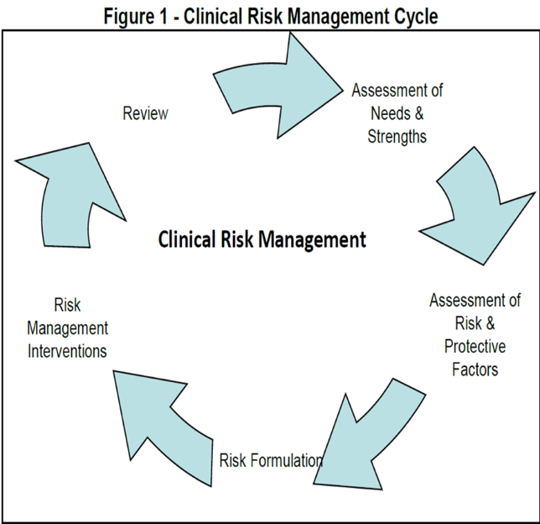
Figure 2: Clinical Risk Management Cycle
Safety Huddles, a brief meeting between unit leaders at the start of each day, support the assessment and management of risk by their focus on safety, risk, increased observations and staffing levels
For further details, please refer to the Trust’s Clinical Risk policy.

8.4 Psychiatric Intensive Care Unit (PICU)
The PICU offers intensive nursing care for those service users presenting as acutely unwell, with higher risks to themselves and/or others that cannot be safely managed on an acute ward. Only patients detained under the MHA can be admitted to PICU.
Admission is usually via transfer from an acute ward, however on some occasions dependant on risk this can be directly from the community or another source including prison.
Patients admitted to a PICU may require use of seclusion facility but this is always a last resort as staff endeavour to use least restrictive practice. PICU patients will be transferred back to an acute ward as soon as risks have reduced enough to be managed on a ward.
In some cases, discharges can occur directly from PICU, however this is on an individual basis, based on need.

8.5 Collaborative care planning
The Trust has a set of standards of care planning to ensure that it is undertaken collaboratively with service users (and carers where appropriate) and reflects a recovery and outcome-based pathway approach. Service users (and their carers) must be offered copies of the care plan, which should evidence that least restrictive principles, practice and language are being utilised.
For further details, please refer to the Trust’s CPA Policy

8.6 Key Care Strategies

8.6.1 Quality Improvement
The Trust’s Quality Improvement strategy supports staff to deliver QI, building capacity and capability. It supports the improvement of services via small projects, through to wholesale service changes which ensure patients have a positive experience of care. The improvement methodologies are consistently applied and support bottom-up improvements, based on reflections of patients and staff, which are implemented and monitored. Current QI projects in North Manchester include Reducing Restrictive Practice, implementing Standards for Acute Inpatient Services in order to reduce Length of Stay. The design of both the new unit, and the model of care reflect improvements which were raised within feedback from patients and staff.

8.6.2 Red2Green
There is good evidence that providing meaningful interactions and interventions throughout an in-patient stay, reduces length of stay and assists recovery. In GMMH, Red2Green provides a focus on resolving issues which impede progress towards discharge, and on having a regular programme of therapeutic activities. By examining the Red and Green status of each patient day, every day, staff are enabled and empowered to identify actions which will reduce delays to recovery and discharge.
Further details on Red2Green can be found within Appendix 2.

8.6.3 Infection Prevention and Control
Infection Prevention and Control is a major element of the design of the new building, ensuring staff and patients have facilities that allow safe care at all times. The design of staff facilities, space for rest and relaxation and well-being, along with surfaces and clinical areas that are welcoming yet meet the stringent IPC requirements are features of the new building. The option of using “swing beds” between the wards, supports business continuity planning, when compartmentalisation is necessary to manage outbreaks of infection.

8.6.4 Positive and safe
In support of its commitment to avoid traumatising/re-traumatising people, the Trust is committed to the Positive and Safe strategy, aiming to reduce any restrictive practices such as seclusion, use of rapid tranquilisation, restraint. Staff will carry out a skilled assessment in order to understand the reasons why a person presents with behaviours of concern, what predicts or triggers their occurrence and what factors maintain and sustain them. A collaborative individualised Positive Support Plan will identify alternative strategies that can be utilised to prevent the need for restrictive practice and support a therapeutic environment, as well as offering opportunities for learning for each individual patient after any episode of restrictive practice.
The environment and staff development will give space and skills to reduce escalation of challenging behaviours and promote diversionary activities, including during periods of enhanced observations.
For further information please see the Trust’s Positive and Safe strategy.[Add in detail about use of de-stim rooms, quiet rooms, indoor and outdoor space – JP]

8.6.5 Safewards
Nursing staff have considerable influence over conflict and containment. The Safeward model identifies six originating domains as sources of conflict and containment. While recognising that there is no single answer and that some factors are outside their control, the Safeward model identifies a range of feasible interventions which are proven to make a difference. See Appendix 3

8.6.6 Safeguarding
All staff have a duty to promote the well-being of adults and where there are adult or child protection concerns, to act to safeguard them from abuse and/or neglect. Staff should ensure familiarity with the Trust’s Safeguarding Policies and local multi-agency procedures. If there are any concerns in relation to actual or suspected abuse and/or neglect of patients or known adults at risk/children, a safeguarding concern should be raised and appropriate action taken to safeguard in line with the local arrangements. Each Trust Division has a Safeguarding Lead who can be contacted for advice and support, alongside line management support.
If the concern relates to a member of staff, the Trust’s Managing Allegations Against Staff Policy should be followed.

8.6.7 Mental Health Act, Mental Capacity Act and DoLS
A high proportion of people admitted to the in-patient facility in North Manchester are detained under the Mental Health Act. Mental Health Act officers ensure the legality of detention of all these people, and Section papers are overseen and retained by the MHA office, who also oversee the organisation of Mental Health Act tribunals.
The Mental Capacity Act (MCA) 2005 and the Deprivation of Liberty Safeguards (DoLS) provide a framework to empower and protect people who may lack capacity to make some decisions for themselves. This includes detained individuals where the care and treatment under consideration is not covered by the MHA (for example necessary physical care that is not directly related to their mental disorder).
Advice about MCA and DoLS is provided by the Mental Health Act management team. Independent Mental Health Advocacy, and Mental Capacity Advocacy is provided by the Manchester Advocacy hub, to support patients making important decisions about medical treatment and changes in accommodation.

8.6.8 Digital Technologies
The use of digital technologies assists all aspects of care within the in-patient unit, including supporting individual interactions between staff in community-based services, and those in-patient wards, participation of geographically disparate staff in multi-disciplinary meetings, and inclusion of patients and carers in discussions about care, as well as enabling patients to keep connected with family and friends. Technological innovations also support the provision of care itself, for example by creating therapeutic environments e.g. soothing lighting, visuals, music, smells within de-stimulation/therapy areas, and the use of innovations such as Ramble guards or observation sensors reducing interventions by staff that disturb patients.

8.6.9 Fire safety
On activation of the fire alarm, evacuation procedures are commenced immediately. The existing Fire Emergency Plans, Procedures & Standing Instructions document will be reviewed to take into account the fire strategy for the new building.

Interventions

8.7.1 Psychological Care
The Psychological stepped care model recognises the importance of the basic psychological ingredients which can be provided by frontline staff, assistant psychologists and experts by experience; with specialist psychological practitioners taking a lead in the governance of such delivery, in the development of psychological informed environments (PIEs) and in the assessment and formulation of the most complex clinical presentations.

Further detail on the Psychological Stepped Care model can be found in Appendix 4

8.7.2 Managing difficult emotions (MDE) pathway
The aim of the MDE offer is aimed at meeting the need for psychological (and physical) safety for individuals who struggle to manage their emotions. This programme should be trans-diagnostic, although people with interpersonal difficulties are particularly likely to benefit.
Further details on the MDE pathway can be found within Appendix 5

8.7.3 Assessment of and support with occupational needs and activities of daily living
All patients admitted to the unit are screened within 72 hours by an Occupational Therapist to ascertain their specific needs. The OT Stepped Care Model is then followed with each patient, including timeframes for review. See Appendix 6
The OTs aim to enable patients to achieve their full potential in occupational performance, health and wellbeing. They work alongside patients in the planning process, agreeing their goals and priorities for intervention, and taking into account the individual’s culture and background and the contexts in which patients engage in occupation on a daily basis.

8.7.4 Support for substance misuse difficulties
It is estimated that at least 50% of patients on in-patient units need support with substance misuse in addition to their mental health needs. Qualified staff participating within the dual diagnosis champions network are able to offer a detailed assessment of a person’s substance misuse, history and presentation which complements that of the wider team, and Pharmacy staff offer support and advice. There are two modes of treatment that could be offered: i) Parallel treatment – (often referred to as joint working) when the mental health and substance misuse agencies work in close collaboration with the patient separately but at the same time. ii) Integrated model in which one service has a form of treatment that delivers treatment for both conditions.

Support with housing issues
Many service users who are admitted into in-patient wards will require support to resolve housing issues, or when their discharge is being planned will need support with future housing. All in-patient wards have access to a housing worker who supports patients with their housing needs. The Older Adults ward has a ward social worker and a resettlement worker.

Support for family/carers.
Support for family/carers is an integral part of personalised and co-ordinated care plans, and their involvement in making shared decisions about care, an important element in the patient’s recovery. Carers should have an understanding of the admission goals, and should be offered their own carer’s assessment. Specific support for a family, may include, for example, Behavioural Family Intervention, for the family of a person with psychosis. Off-ward family visiting rooms will support patients in maintaining contact with their families and in particular their children.
Older adults services have access to the Admiral Nursing service, whose specialist dementia nurses give expert practical, clinical and emotional support to families living with dementia.
Older adults services also have access to Systemic (Family) therapy which explores the connections between people, their families and other important people in their lives. Resolving difficulties might involve: listening well and understanding the perspectives of each other, trying different ways of doing things together, starting to recognise and showing more of their collective strengths and resources. The therapy is carried out by a Psychologist and older adult staff trained in systems therapy.

Support with physical health
It is known that people with serious mental illness have a higher incidence of poor diet, cardiovascular and respiratory diseases, diabetes and hypertension. An in-patient stay is an opportunity for specialist staff to offer support and advice to promote good physical health. Referrals can be made for physical health checks, nutritional advice and exercise-based support from Specialist physical healthcare nurses, Physiotherapists, Dietitians, Speech and Language therapists and Podiatrists.
Referrals, particularly for older adults, may also be made to other services including audiology, tissue viability services and old age physicians.

Medicines Management
Staff and patients have access to the clinical pharmacy team throughout the inpatient stay. Pharmacists are available to provide expert information about medications for both physical and mental health, supporting patients to make informed choices about their medications both verbally and with the use of printed information from the choice and medication website. They will provide education sessions to individuals or groups of patients when required, and as members of the MDT, advise individual patients during admission and prior to discharge to enable better concordance with medication.

8.7.9 Electroconvulsive Therapy (ECT)
Electroconvulsive Therapy (ECT) is an essential intervention for some service users who attend treatment from both the inpatient wards and community settings. ECT can be a life-saving treatment for some and is the definitive treatment for catatonia of any cause and life-threatening depression. ECT is used in approximately a million people per year globally, in every advanced health system.
The possibility of receiving ECT can be frightening, and service users should receive information on the pros and cons of this treatment, and have the opportunity to discuss these in full with the clinical team.
ECT is regulated in the United Kingdom by NICE (with respect to indications) and the RCPsych’s ECT Accreditation Service (with respect to implementation). As well as 3-yearly audit and peer review by ECTAS, the service is subject to annual internal audit. The ECT service comprises a multidisciplinary team led by a consultant with a special interest in ECT, and includes anaesthetists, nurses and operating department practitioners (ODPs) from North Manchester General Hospital. All staff have a special interest in ECT and attend regular national courses and conferences both as delegates and trainers.
For ECTAS accreditation, the service must be provided in a dedicated suite which must meet recommended patient-centred and safety and dignity-focused environmental and procedural standards. Treatment occurs twice per week in line with NICE guidance. As people receiving ECT must fast before each treatment, treatment occurs in the morning. Treatment is provided in conjunction with the referring team, who receive advice on medical fitness, frequency and duration of treatment, medication, indications, side effects and prognosis from the ECT MDT.

8.7.10 Suicide prevention
[Add in Suicide Prevention section – SL]

8.7.11 Audit
In addition to the routine collection of performance monitoring data, the quality of care and efficacy of interventions in services is under constant review. It is supported by participation in national Confidential Enquiries and audits, and local audits of care. These are in addition to an annually agreed programme of Quality Improvement projects. A sample Annual Audit programme is attached at Appendix 7

Discharge planning
Please refer to local discharge planning checklists in addition to these guidelines.
Discharge planning will commence at the point of admission for all patients regardless of which ward they are admitted to or discharged from, and whether they are admitted informally or detained under the Mental Health Act.
Each patient will have an expected date of discharge agreed at the point of admission which will be reviewed during both board round and ward review meetings.
Standards and guidance on Board rounds and Ward rounds can be found in Appendix 8 and Appendix 9
There will be an initial CPA meeting where a collective agreement is reached with the referring team, CMHT and inpatient staff regarding the purpose of the inpatient stay, discharge criteria and likely length of stay.
The pre-discharge discussions and decision to discharge should, where possible, be made in conjunction with the patient and carers.
Pre Discharge
- MDT will arrange and attend Discharge CPA for all patients approaching discharge.
- MDT will review cluster at Discharge CPA to reflect overall care package requirements.
- Pharmacy team will review medications to be taken away, advise on their continuation and liaise with outside agencies about continuation of specific medications eg. clozapine
- Occupational Therapists will produce a report for consideration by the MDT for all patients accepted onto a caseload in time to influence discharge planning.
- Relatives and/or carers will be invited to a pre-discharge meeting
At discharge
- All patients will have a discharge prescription completed
- All patients will be offered an exit questionnaire
- All patients will be supported to develop a “discharge account” that includes their experience of the admission
- Patients will be aware of what follow-up they should expect and what support they can access
- All patients will be given a written appointment for their next contact and contact information for their team.
- A discharge notification will be sent to everyone identified in the plan as involved in the patient’s ongoing care, within 24 hours of discharge from inpatient services
- A discharge summary will be completed within 10 working days of discharge and a copy sent to the patient’s GP via an approved method i.e. NHS email/ECC/Royal Mail (in line with the standards agreed with Manchester commissioners)
Following Discharge
- All patients will receive follow up within 72 hours – preferably face to face from their Care Co-ordinator, or HBT.
- All patients will be seen for a follow-up appointment

Supportive Discharge Planning
Staff should be planning for discharge, including key aspects of a patients’ long term recovery from the beginning of admission. This should include planning how to respond quickly to a readmission by the patient.
Discharge planning should be person-centred, particularly in care planning. It should be recovery-focussed with a shared understanding of what recovery means for the individual patient. It should be consistent in its processes, supporting effective discharge with patients empowered to take ownership of their own recovery.
The role of the carer, friend or family member is critical in supportive discharge. They should be seen as an essential part of a patient’s care and there can be great benefits in them being part of the multi-disciplinary team delivering care and treatment following an in-patient stay.

8.8.2 Rehabilitation
For some patients, their discharge from an acute ward will be into a rehabilitation setting where recovery-focused support will enable service users to develop, enhance and sustain life skills and coping strategies, so enabling them to achieve greater independence and quality of life.​ Rehabilitation services are run by GMMH and 3rd sector organisations, but there is a single route of referral managed by GMMH into all rehabilitation services.

8.9 End of life care
Within any hospital setting it is inevitable that there will be instances when deaths occur and it is likely that some inpatients will be found to be in the last days or hours of their life. In these circumstances an individualised end of life care plan will be developed to meet the dying person’s needs and wishes in relation to any preferences they may have expressed. This plan will ensure that those identified as important to them, are involved in decisions about treatment and care to the extent that the dying person wants. The needs of families and others identified as important to the dying person will also be actively explored, respected and met as far as possible.
Care will be provided in a suitable environment maximising visiting by those close to the patient and ensuring attention to symptom control and the person’s physical, emotional, psychological, social, spiritual, cultural and religious needs. The plan will also encompass the person’s needs in relation to their mental health.
The inpatient team providing end of life care will proactively liaise with palliative care services and where appropriate with the chaplaincy team.

8.10 Care of patients with Dementia
Dementia is a condition affecting the memory and cognitive functions, often resulting in misinterpretations and confusion, together with difficulties with self-care and maintaining personal safety. The individualised care plans will reflect the full range of needs caused by dementia and will be developed in partnership with the person with dementia’s family and carers.
People with dementia are likely to become agitated in unfamiliar surroundings. Providing visual clues and prompts to help them find their way around is particularly important. There will be signs using both pictures and text placed at a height where they can easily be seen. Personalising bed spaces and providing clocks and calendars will help with orientation.
It is recognised that the environment promotes meaningful interaction between patients, their families and staff. This will be achieved by providing a choice of seating, older people are likely to need chairs with arms, and arranging chairs in clusters will encourage conversation. Taking part in activities will help to relieve anxiety and promote interactions between patients.
The environment can also promote well-being for example older people need higher light levels and this can reduce the risk of misinterpreting the surroundings. Also having personal objects will be reassuring and help promote self-care, and access to the outside is important for well-being.
Having a choice of where to eat, e.g. with others or by themselves, may encourage people to eat and drink. The involvement of SALT and dietitian as part of the ward care team is very important in overcoming possible poor pre-admission nutrition and managing the risk of impaired swallowing.
Being able to walk independently is important but can also represent a risk. In all cases there will be an assessment of mobility and falls risk completed by a physiotherapist. For some people with dementia the availability of space to wander can be an important element in managing agitation. Safety can be enhanced by providing handrails and small seating areas where people can rest.
Not being able to find the toilet provokes anxiety and using the same signs and door colours to denote all toilets will help people find them more easily. Ensuring good colour contrast on sanitary fittings will make toilets and basins easier to see and use. Traditional and familiar designs will help ease anxiety and promote self-care.

Staffing model to deliver this service offer
In order for all wards within the new unit to deliver this service offer, a multi-disciplinary staffing complement will be available. Within each ward complement, specific roles will be allocated within the team on each shift.
- Shift Co-ordinator. During each shift a qualified nurse will act as the shift coordinator with responsibility for delegating, prioritising and organising all duties and responsibilities of the nursing team.

- Response staff. Staff members are allocated to this role by the nurse in charge on each shift, and apply to any staff who are PMVA trained and qualified. They participate or provide PMVA intervention support, ensuring that service users and others are safeguarded from risks of physical violence and aggression, in adherence to the principles of Positive and Safe GMMH policy.

- Security nurse. The Security Nurse ensures awareness of all Service Users’ whereabouts and their safety, and participates in ensuring that service users are protected from any form of abuse.

- Named nurse. Each service user is allocated a named nurse who is responsible for the assessment, treatment and care planning in collaboration with the individual and their carer or significant other and trust-wide care team.

See Appendix 10 for further details of the staffing model.

Partnerships and interfaces

10.1 Working with carers and families
With consent, the named nurse/nominated staff should actively engage carers in the care and treatment plans. This includes being routinely invited to ward review meetings, and being involved in identifying placements.
Bookable off-ward family visiting rooms are available for planned visits and visiting times are scheduled to promote maintenance of contact with families and carers.

10.2 Working with patient flow
The Patient Flow Team deliver a hub and spoke model for Adult services, with the hub operating from Prestwich site. Each division has a Senior Practitioner for Patient Flow based locally on site who works Mon-Friday 9-5.
They participate in the 3 times daily huddles/teleconferences between wards and Patient Flow, using digital technology to maximise their presence and participation.
Outside of normal working hours – Patient Flow can make contact with bleep holder / Unit Co-ordinator or direct to the nurse in charge of the ward to arrange admissions / request information around capacity.
A Senior Practitioner for Patient Flow chairs the boardround and attends ward reviews, and professionals meetings as needed, either in person or virtually via digital technology.
The Senior Practitioner is the HBT trust assessor.
See GMMH Patient flow Standard Operating Procedure Appendix 1
For Older Adult services, ward staff participate in a daily call with the CCG in relation to patients whose discharge is delayed either because of Delayed Transfers of Care (DTOCs) and Medically Optimised and Awaiting Transfer (MOATs)

10.3 Working with Home Based Treatment and Intensive Support Service
The Home Based Treatment (HBT) staff will:
- Provide effective use of inpatient resources by gatekeeping all admissions, establishing a purpose for admission, inpatient treatment plan or signposting to relevant services. This is recorded on the ATAC (section 1-4)
- Attend medical reviews and professionals meetings on the inpatient unit either in person or via the use of digital technology
- Attend the ward to meet patients prior to their discharge to discuss their discharge plans if being discharged to HBT
- Be actively involved in the discharge planning process to identify those service users who can be discharged with intensive input from home based treatment
- Support periods of leave from inpatient unit to support timely discharge planning
- Ensure that when discharged, patients have appointments with HBT or CMHT for statutory follow up. The use of digital technology will assist in contacting patients and support patients in attending virtual appointments when appointments in person are challenging
- Older Adults have a step up/step down process with use of the Therapy Hub to avoid admission/speed discharge.
The HBT teams can be contacted via telephone, MS Teams, or face to face (when based on site) to discuss service users’ cases and make referrals into the team.

10.4 Working with CMHTs
The Care Co-ordinator is the navigator of a service user’s care and treatment and remains central in partnership with the patient and inpatient team to ensure progress during their admission.
The ward staff will advise care co-ordinators of MDT ward reviews to promote multi-disciplinary engagement and working to expedite timely effective discharge planning. Care Co-ordinators should be invited to the first ward review MDT meeting, which they can attend in person or using digital technology, and then agree future attendance. Particularly where there are barriers to discharge then Care Co-ordinators would be expected to regularly attend ward review in person or virtually, to feedback on referrals / progress etc.

10.5 Working with the Local Authority
Social workers represent the Local Authority in carrying out functions described in statute, including best interest processes, and the Court of Protection. In Manchester, Social Workers are employed by GMMH, and they are part of the MDT assessing a patient’s entitlement to Section 117 aftercare, or whether they meet the National eligibility criteria of the Care Act. The use of digital technology will support their attendance at MDT meetings.

10.6 Working with the acute Trust
Advice on medical conditions for patients on wards in the acute mental health unit can be accessed from medical colleagues in the acute Trust and SLAs are in place to support this.
The mental health liaison service provides support into the acute hospital, for in-patients who need mental health advice. The liaison service also provides support for mental health inpatients who have been transferred into the acute hospital, whether for short or longer term treatment, and the pharmacy team liaises with the acute Trust pharmacy team to resolve any medication-related issues.
Please refer to Trust policy for Transfer of service users to acute care Appendix 11
GMMH has a SLA with the acute Trust for the provision of a response to a cardiac arrest within the acute mental health unit. The acute Trust’s Cardiac Arrest Resuscitation Team is activated on receipt of a “2222” call from GMMH, to support the response of GMMH ILS-trained staff who are rostered on wards 24hrs/day.

Record keeping
The ability to hold consistent, reliable, timely and available records is key to ensuring that our service users and patients are able to receive optimal care. All organisations involved in the care of patients have a duty to ensure that they are recording accurate information relating to the holistic care of the patient in front of them. It is common place for many different professionals across a range of organisations and disciplines to have responsibility for specific elements of a patient’s treatment pathway; it is essential that records are maintained and are available for review at the point of care; without access to these records there is a danger of introducing clinical risk and providing sub-optimal care. All organisations involved in caring for our patients and service users have a duty to share records securely and within appropriate governance arrangements, ensuring that access is available 24/7.

11. Facilities supporting recovery
There are a number of off-ward facilities within the in-patient unit, supporting the recovery of patients during their admission.

11.1 Café
The café is a facility for all - patients and their visitors and staff. Within the Trust’s service user engagement strategy it will be managed by peer mentors/volunteers, and its location near the entrance but within the in-patient unit will enable it to be accessed by patients, visitors and staff who can leave the ward without leaving the unit.

11.2 Gym
There will be a gym available for use by in-patients, under the supervision of appropriately trained staff and located in a shared space. Prior to use, a risk assessment will be completed by the MDT to ensure that the patient is allowed leave from the ward to use the gym. A physiotherapist will complete the screening to determine the appropriate type and extent of exercise.

11.3 Exercise space
A bookable Exercise room, adjacent to the gym, but separate from it, is available for the provision of exercise classes. It provides an exercise space for patients who may not be able or wish to use the gym, but are able to undertake group exercise under supervision.

11.4 Spiritual hub
The spiritual hub is an essential feature in recognising the centrality of faith and spirituality in the lives of many in-patients and ensuring that the new development is culturally appropriate for all those it serves. Multi-purpose rooms, as well as single space bedrooms within the wards can be used for prayer or religious observance, but the room in the shared space will be used solely for religious and spiritual observance and specific therapeutic activities in keeping with multi faith room such as meditation, mindfulness, relaxation.

